ML Mini Project — Documentation
Name: Gautham VR
Batch / Track: April-October (Afternoon)
Project title: Customer Churn Prediction GitHub link: https://github.com/gvr6/customer-churn-prediction
Last updated: 2026-09-13

1. Business Problem
What problem are you solving? (3–4 sentences)

Customer churn is an important problem for subscription-based businesses. When customers stop using a service, it can result in revenue loss and reduced customer retention. This project uses machine learning classification techniques to predict whether a customer is likely to churn based on customer tenure, usage, and support-related information.

Who has this problem, and what is it costing them?
Subscription-based businesses face the challenge of identifying customers who are likely to leave. Customer churn can result in loss of recurring revenue and can also increase the effort and cost required to acquire new customers.

Why can't a simple rule or filter solve it?
Customer churn can be influenced by multiple factors such as tenure, total usage, and support ticket count. A simple rule based on a single factor may not capture the combined patterns in customer behaviour. Machine learning models can analyze multiple features together and provide churn predictions.

2. What You Are Building
What will your model predict?
The model predicts whether a customer is likely to churn or remain with the service. The prediction is based on customer tenure, total usage, and support ticket count.

Is it classification, regression, or clustering?
This is a binary classification problem because the model predicts one of two classes: Churn or No Churn.

How would the business actually use the output?
The business can use the predicted churn results to identify customers who may be at risk of leaving. These customers can be prioritized for retention activities such as targeted communication, additional support, or suitable offers.

3. Data
Name of the datasets?
The project uses five datasets:
- account_master.csv
- usage_logs.csv
- support_tickets.csv
- churned_labeled.csv
- churned_to_predict.csv

How many rows and columns?
• account_master.csv: 392 rows, 5 columns
• usage_logs.csv: 4,715 rows, 5 columns
• support_tickets.csv: 1,161 rows, 5 columns
• churned_labeled.csv: 334 rows, 2 columns
• churned_to_predict.csv: 58 rows, 1 column

What is the target column?
The target column is churn.

How is the target distributed? (e.g. 88% No / 12% Yes)
The target variable is distributed as 75.15% No Churn and 24.85% Churn. Out of 334 customers, 251 customers are classified as No Churn and 83 customers are classified as Churn.

Which columns are you using, and what does each one mean?

Column | Type | Meaning
tenure_months | Numerical | Customer has been with the service for how many months
total_usage | Numerical | Total usage of the service by the customer
ticket_count | Numerical | Number of support tickets raised by the customer

What is wrong with this data? (missing values, imbalance, old data, small size — be honest)
The dataset has some missing values in the usage and support-ticket features because not every account has usage logs or support tickets. These missing values were handled by replacing them with 0, assuming that no record means no recorded usage or tickets. The dataset is also relatively small, with 334 labeled customer accounts, so the model may not generalize well to a much larger customer base. The churn classes may also be imbalanced, which can make accuracy alone less reliable for evaluating the model.

4. Data Preparation
How did you handle missing values? (which columns, what method, why)
Missing values were mainly present in the aggregated usage and support-ticket features. These missing values occur when an account has no corresponding usage log or support ticket record. We replaced the missing values with 0 using fillna(0), because the absence of a record represents zero recorded usage or zero support tickets.

How did you handle outliers?
No specific outlier treatment was applied. The project used aggregated total_usage and ticket_count features, and no rows were removed or values capped based on outlier detection. This was kept simple because the project focused on building a basic churn classification model.

How did you encode categorical columns? (one-hot, label, target encoding)
No categorical encoding was required. The model used only numerical features: total_usage and ticket_count. The account_id column was used only for merging datasets and identifying customers, and was not used as a model feature.

Did you scale anything? Which columns and why?
StandardScaler was applied to the numerical features tenure_months, total_usage and ticket_count for KNN and Logistic Regression. Random Forest used the original numerical features.

Did you create any new features? What and why?
Yes. total_usage and ticket_count were created by aggregating usage logs and support tickets by account_id. tenure_months was taken from the account master data.

How did you split the data? (ratio, random_state, did you stratify)
The data was split into 70% training and 30% testing using random_state=42. Stratification was used to preserve the churn class distribution.

5. What You Found in the Data

1. Customer Churn Distribution

- Chart: Churned vs Non-Churned Customers — Bar Chart
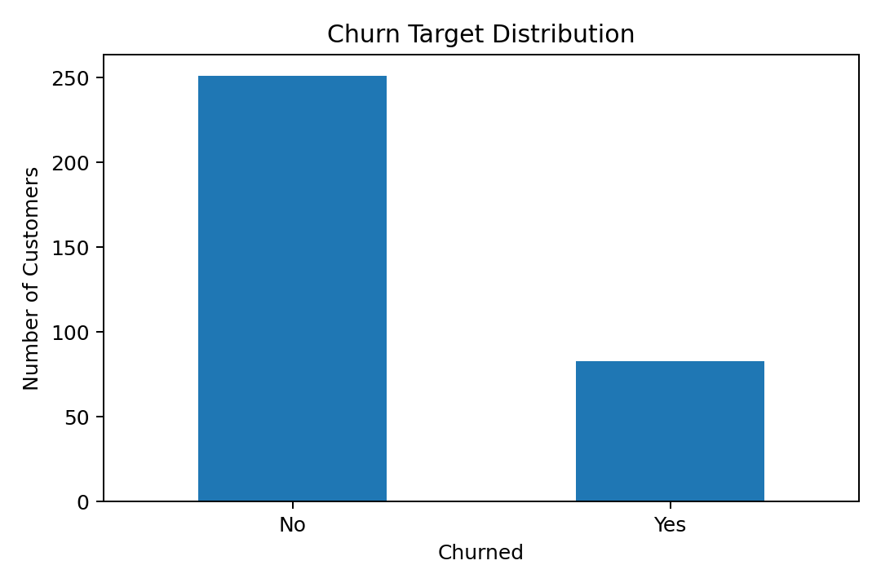
- What it means: The labeled dataset contains 251 No Churn customers and 83 Churn customers. About 75% are No Churn and 25% are Churn, so the target classes are imbalanced.

2. Total Usage Distribution

- Chart: Distribution of Total Usage — Histogram
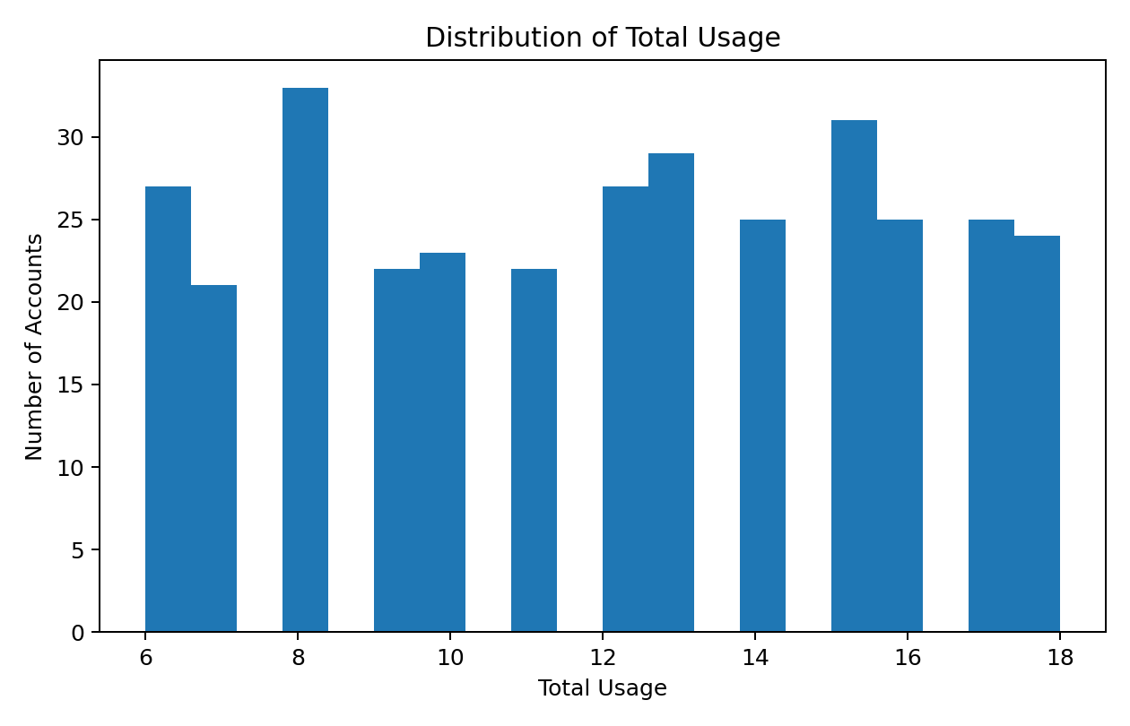
- What it means: Customer total usage varies across the dataset. The histogram shows the spread of usage counts and helps identify the typical range of customer activity.

3. Support Ticket Distribution

- Chart: Distribution of Support Tickets — Histogram
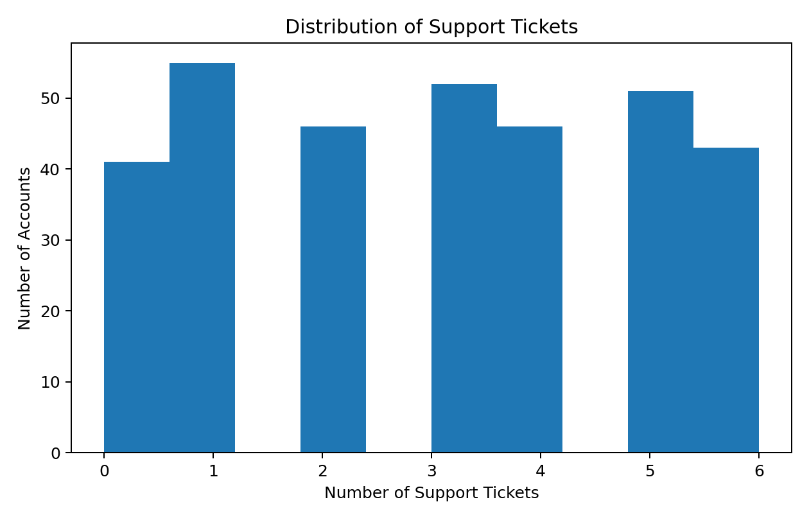
- What it means: Support ticket counts vary across customers. Most customers have relatively few tickets, while a smaller number have higher support activity.

6. Models
Baseline model and its score: A DummyClassifier using the most_frequent strategy was used as the baseline. It achieved 75.25% accuracy on the stratified 30% test set.

Which models did you try?

Model | Why you chose it | Score | Notes
KNN | Simple classification model and useful baseline comparison | 72.28% accuracy | Features scaled with StandardScaler; n_neighbors=5
Logistic Regression | Simple linear classification model for comparison | 75.25% accuracy | Features scaled with StandardScaler; standard Logistic Regression
Random Forest | Handles nonlinear relationships and provided the best overall result | 76.24% accuracy | n_estimators=100; class_weight='balanced'

How did you tune it? No GridSearchCV or RandomizedSearchCV was used. KNN used n_neighbors=5. Logistic Regression used max_iter=1000. Random Forest used n_estimators=100 and class_weight='balanced'.

7. Evaluation
Which metric did you use?
Accuracy, precision, recall and F1-score were used to evaluate the classification models, with attention to recall and F1-score for the Churn class because the target is imbalanced.

Why that metric and not accuracy?
Accuracy alone can be misleading because the dataset contains more No Churn customers. Recall shows how many actual churn customers are detected, while precision and F1-score help measure the quality of churn predictions.

Confusion matrix / error plot: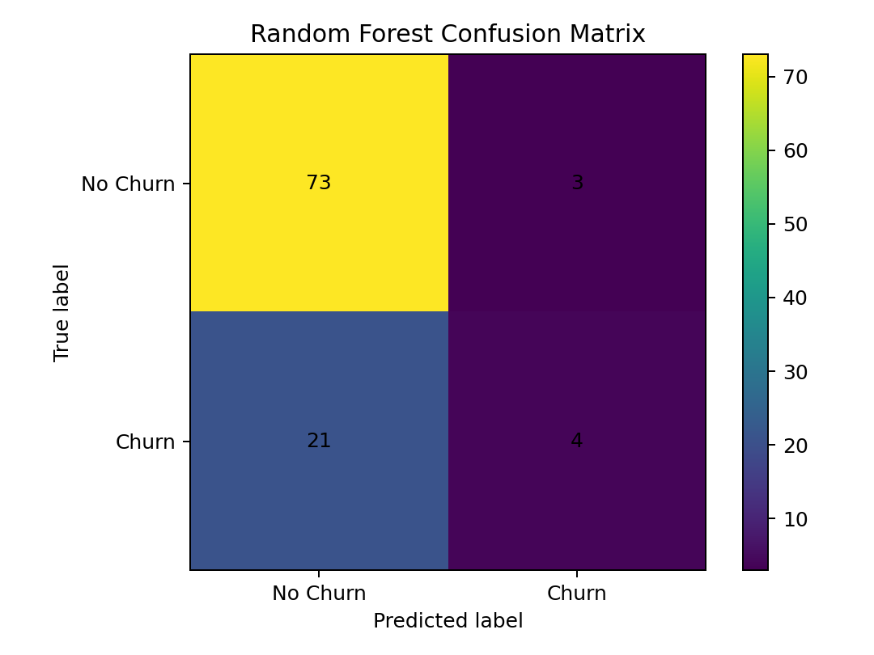
The Random Forest confusion matrix shows that 73 No Churn customers and 4 Churn customers were correctly classified. It incorrectly classified 3 No Churn customers as Churn and missed 21 actual Churn customers.

Where does the model get things wrong most often?
The Random Forest model gets things wrong most often when identifying Churn customers. It correctly identifies 4 out of 25 actual churn customers, giving a churn recall of 16%.
Final model selected, and why:
Random Forest was selected as the final model because it achieved the highest accuracy among the tested models at 76.24%. It also had the highest churn precision (57%) and churn F1-score (25%) among the three main models, although its churn recall was only 16%.

8. Findings & Business Benefit
What does your score mean in plain words?
The Random Forest model achieved 76.24% accuracy. In the test set, it correctly classified 77 out of 101 customers. For the Churn class, it correctly identified 4 out of 25 actual churn customers, giving a recall of 16%.

What can the business do differently now?
The business can use the model to identify customers who are more likely to churn and take preventive actions before they leave. These customers can be targeted with personalized offers, discounts, improved support, or follow-up communication. This can help reduce customer loss and improve customer retention.

Who would use this, and how often?
The customer success, marketing, and support teams can use the churn predictions to identify high-risk customers. The predictions can be reviewed regularly, such as weekly or monthly, so that appropriate retention actions can be taken at the right time.

9. Challenges Faced

Challenge 1
Stage | Data / Cleaning / EDA / Modelling / Evaluation
Problem | The target classes were imbalanced, with 75.15% No Churn and 24.85% Churn.
What you tried | The initial Logistic Regression model predicted no Churn for all churn cases, giving 0% churn recall.
What worked | Used class_weight='balanced' in Logistic Regression and evaluated recall and F1-score.
Result | Balanced Logistic Regression increased churn recall to 48%, although Random Forest was later selected as the final model.
Challenge 2
Stage | Data / Cleaning / EDA / Modelling
Problem | Customer information was stored across account, usage and support-ticket datasets.
What you tried | Tried combining the datasets using account_id.
What worked | Merged the datasets and aggregated usage and ticket counts at customer level.
Result | Created a final customer-level dataset with tenure, total usage and ticket count.
Challenge 3
Stage | Modelling / Evaluation
Problem | The three main models produced different accuracy and churn-class metrics.
What you tried | Compared KNN, Logistic Regression and Random Forest.
What worked | Used accuracy, precision, recall and F1-score to compare the models.
Result | Random Forest was selected as the final model with 76.24% accuracy.

10. Limitations & Next Steps
What can this project not do?
The project cannot reliably identify every customer who will churn. Its churn recall is 16%, so many actual churn customers are still missed. The model also uses only three main features and a relatively small labeled dataset.

Three things you'd fix with more time:

1. Improve the model's ability to identify actual churn customers by further tuning the classification threshold and model parameters.

2. Use more customer data and additional features such as customer satisfaction, contract details, and historical churn patterns to improve prediction performance.

3. Build a simple dashboard that allows the business team to view churn predictions, high-risk customers, and important model metrics easily.

11. Tech Stack
Language and version:
Python 3.10.6

Libraries used:
Pandas
NumPy
Matplotlib
Scikit-learn
Jupyter Notebook

